Introduction

This is not an official firmware release from Seeed Studio. The BenF V3 firmware has been developed to overcome some of the limitations and issues with the official firmware releases. In particular this applies to improved SD card support, a more advanced no loss sampling algorithm and a more intuitive user interface. The firmware is developed on a Seeed Studio DSO Nano V1, but is believed to work equally well with DSO Nano V2. It may or may not work with hardware supplied by other manufacturers.

The firmware is free of charge to individuals in its binary format and is put into the public domain in the hope that it will be useful for others and not only the author. Any use of this firmware is at your own risk. No express or implied warranty is granted for the firmware or related documentation and under no circumstance can the author be held responsible for any direct or consequential damage that may arise from using it.

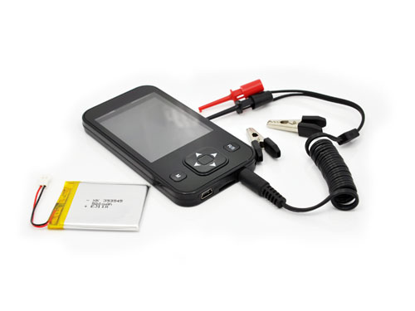

Background

The DSO Nano project originated as an open source effort. Unfortunately these contributions appear to have been cramped by individuals with limited programming skills and even with the most recent official firmware 2.5e release we’re not much further than a pretty enclosure with potential. To release this potential a complete rewrite of the firmware was needed.

A proper digital scope needs a three phase approach to sampling. That is pre-fetch, trigger phase and post fetch. The trigger phase must continue until a trigger is found (forever if need be) while the sampling buffer is continually reused in a round-robin fashion (no samples must be lost or disregarded in this phase). When a trigger condition is met, post fetch will start and when completed all sampled data will be displayed with the trigger point centered on the screen. Unfortunately this is not the way 2.5e and prior versions work. The approach taken with the official DSO Nano firmware is the simplistic single buffer capture followed by trigger search. This makes it more or less unfit for digital analysis (e.g. SPI, I2C, RS-232, RS-485) and also of limited use for signals like electronic ignition (narrow, infrequent pulses) and many (if not most) other real life measuring and fault finding challenges.

Thanks to Seeed Studio however, the current software is open source and based on the 2.5e source release, I’ve rewritten it to fix the more fundamental issues. Fixes and features include the following:

- Proper three phase sampling (pre-fetch, trigger-fetch, post-fetch) guaranteed never to miss infrequent events
- More efficient screen update (10-100 times faster than version 2.5e)
- Eliminate all flickering and stuck pixels
- Code is re-written to allow full compile time optimization (much faster and compact code all over)
- A bug in Vrms calculation is fixed (Vrms is incorrect in 2.5e)
- A number of overflow bugs have been fixed (calculations for large time/div settings)
- Scan has been replaced with a proper continues real-time scan mode
- Configuration profiles can be saved to /restored from SD card or flash (default power on settings).
- Wave data (reference signals) can be saved/restored from SD cards
- Screen capture can be saved to SD bitmap files
- A number of issues with incorrect SD card support and file handling in 2.5e have been fixed
- FIT mode is implemented as a function
- The full captured signal buffer (3000+ points) can be panned left right for further analysis
- A more relevant collection of data is selected for display on screen
- A more relevant selection of measurements
- Simultaneous view of all measurements
- Use proper ISO abbreviations (e.g. milliseconds is “ms” not “mS”)
- A completely redesigned user interface (no annoying blinking or color abuse)
- Support two step calibration (offset and range)
User Interface

All menu items are available from the right hand side of the display. These are organized in the following main groups:

VD | Voltage/Div | Select voltage (y-axis) scale
TD | Time/Div | Select time (x-axis) scale
YA | Y-axis | Set horizontal cursors and ground position
XA | X-Axis | Set vertical cursors and trigger position
TR | Trigger options | Choose trigger mode, level, sensitivity and kind
ME | Measurements | Select or display measurements
FI | File options | Options for reading and writing from/to SD cards and Flash memory
FR | Frequency | Select output frequency
OT | Other | Select probe attenuation and options for calibration

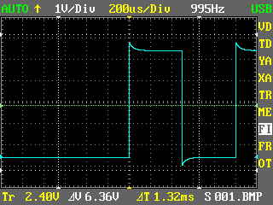

Use arrow up/down to move between menu groups. Moving past upper/lower wraps around to other side. Within each group there are one or several sub-commands. As an example YA (Y-axis) have sub commands for V1 Cursor, V2 Cursor and Gnd position. Use the “M” button to display a popup window with supported sub-commands, up-down to change selection and M to close the popup.

Use left/right to change the setting of the active command within the currently selected group. Use either the B button (DSO Nano V2) or a long press of M to show/hide cursors or save/load files.

Choose Trigger Mode (TR group) and press B (or long M) to activate the FIT function.

Choose Time/Div greater or equal to 100ms to activate real-time scan mode (use Auto trigger for test).

Panning left/right is achieved with menu item XA (X axis) and sub option “Trig Pos”. Using the left/right arrows, you offset the trigger position in steps of 1 horizontal div. Using this technique, you can pan left/right to see the full waveform captured (more than 10 full screens). To stop capture, you can use either the SING trigger mode or use NORM/AUTO in combination with R/S. When panning left/right, pressing “B” (or long “M”) will reset trigger point back to center. Pressing “B” (or long “M”) when at center, will alternately show/hide the trigger position axis.

Preferences can be saved to SD card for recall or to Flash memory to act as power on defaults. First, use the various menu options to configure DSO Nano any way you prefer. Then choose menu "FI" and sub-option "Save Pro". Choose profile zero (S Flash) and press "B" (or long "M"). This will save all active settings to DSO internal flash memory for use as power on defaults. Profiles other than zero (e.g. S 001.CFG ) will be saved to SD card and can be recalled with sub-option "Load Pro".

A two-step basic calibration scheme is supported. First choose “DC V” as active measurement. Then apply ground level to the input probes and choose menu “OT” and sub option “Cal Offs” to calibrate ground offset. Use left/right arrow until you have a zero DC voltage reading. Then apply a known voltage reference to the input probes and use sub option “Cal Range” to calibrate range. Use left/right arrow until you have a DC voltage reading that match your input voltage reference. Range calibration is applied as a percentage of full scale in +/- 0.5% increments. Pressing “B” (or long M) will reset calibration to zero.

Installation

Please refer to sources on the Seeed Studio DSO Nano forum for detailed instructions on how to upload the firmware. You need to upload both the DSO BenF APP v3.xx.dfu and DSO BenF LIB v3.xx.dfu. The order of upload (LIB or APP) is not significant.

Micro-SD cards must use either the FAT16 or the FAT32 file system (NTFS and exFAT is not supported). High capacity SD cards (SDHC) are not supported. SD cards must support the SPI access protocol. I’m using a 2GB SanDisk card supplied by Seeed Studio that works well with the new V3 firmware. The FAT16 file system appears to be slightly more responsive on Windows XP (after writing a new image file to the card). This may or may not be the case on other platforms.

The DSO Nano has only limited SD read/write capabilities. New files can not be created (or expanded) and so template files must be copied to the SD card prior to using the read/write options from the DSO Nano. A set of sample files is included with this firmware (FILE001.CFG, FILE001.DAT and IMAGE001.BMP). If you need additional files, you can make copies of and rename the provided template files. Use “FILExxx.CFG” for profiles, “FILExxx.DAT” for reference waveforms and “IMAGExxx.BMP” for screen captures. Substitute “xxx” with numbers from “001” to a maximum of “255” for each file type.

